Defect Picture Dated 2026-04-06
STYLE NO : 01276N062C-BOTTOM-AFTER WASH

STYLE NO : 01276N062C-BOTTOM-AFTER WASH
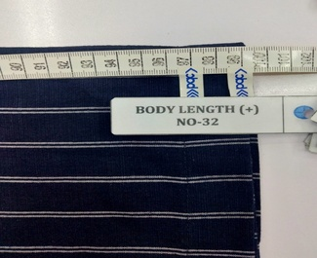
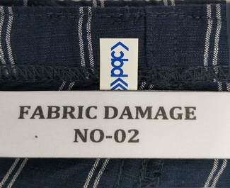

STYLE NO : 01276N062C-BOTTOM-AFTER WASH
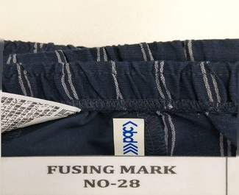
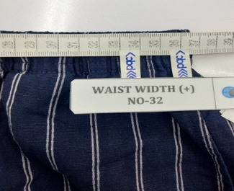

STYLE NO : 01276N062C-BOTTOM-AFTER WASH
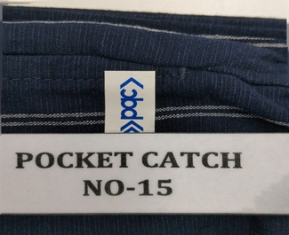
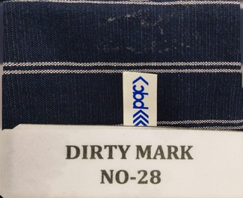

STYLE NO : 01276N062C-BOTTOM-AFTER WASH
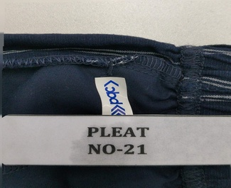
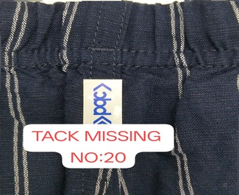

STYLE NO : 01276N062C-BOTTOM-AFTER WASH
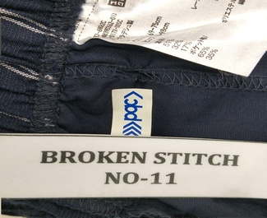
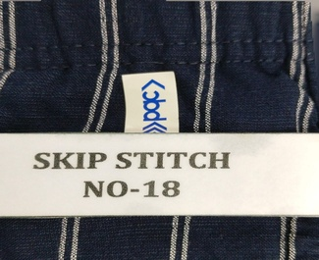

STYLE NO : 01276N062C-BOTTOM-AFTER WASH
